Azure resource hierarchy

Management Groups (The Top-Level)

What it is: This is the highest level of Azure’s structure. It's like a parent folder that helps organize your entire Azure environment.

Purpose: It helps you manage and organize multiple subscriptions across your organization. You can group subscriptions based on departments, teams, or projects.

Example: Imagine a company with multiple divisions, like Finance, IT, and Marketing. You could have separate management groups for each of these divisions.

Subscriptions (Middle Layer)

What it is: Underneath management groups, you have subscriptions. A subscription is like a container for Azure resources, where you’ll define limits on resources and billing.

Purpose: It helps with organizing resources, managing access, and billing. You can have multiple subscriptions for different projects or teams. Each subscription has its own resource limits and billing.

Example: If your company has different projects, like a website and an app, you could create separate subscriptions for them. One for the website, one for the app.

Resource Groups (Sub-Containers)

What it is: Inside each subscription, you can have resource groups. These are containers that hold related resources.

Purpose: They help organize resources based on their lifecycle and permissions. All the resources in a group are usually related to the same project or service.

Example: If you're building a web app, you might have a resource group called "rg-ohg365-dev" where you store everything related to the app, such as databases, storage accounts, and virtual machines.

Resources (The Actual Items)

What it is: These are the individual services or products that you create in Azure, like virtual machines (VMs), storage accounts, databases, or networks.

Purpose: This is where the actual work happens! Resources are the building blocks of your cloud environment.

Example: In your "rg-ohg365-dev" resource group, you could have resources like a VM to run your website, a database to store your data, and a storage account for storing files.

Management Groups: High-level containers for organizing multiple subscriptions.

Go to the Azure portal and search for Management Groups.

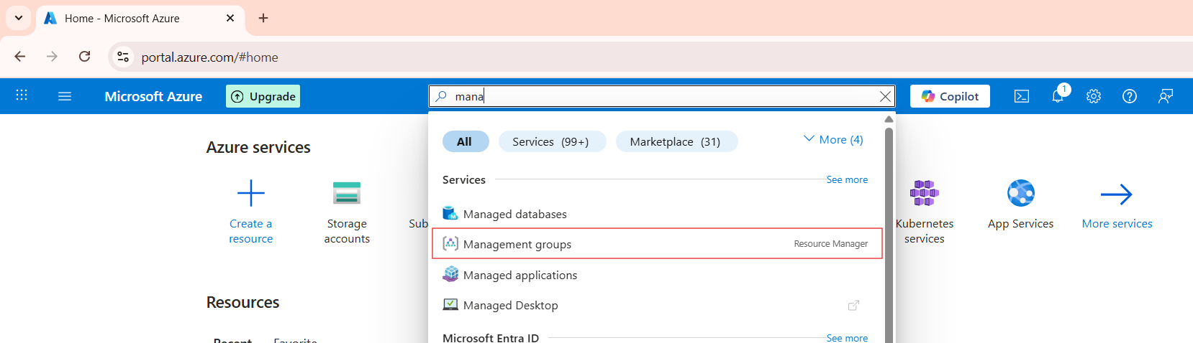

After clicking the management group, all subscriptions under that group are displayed, and the corresponding subscription is automatically highlighted.

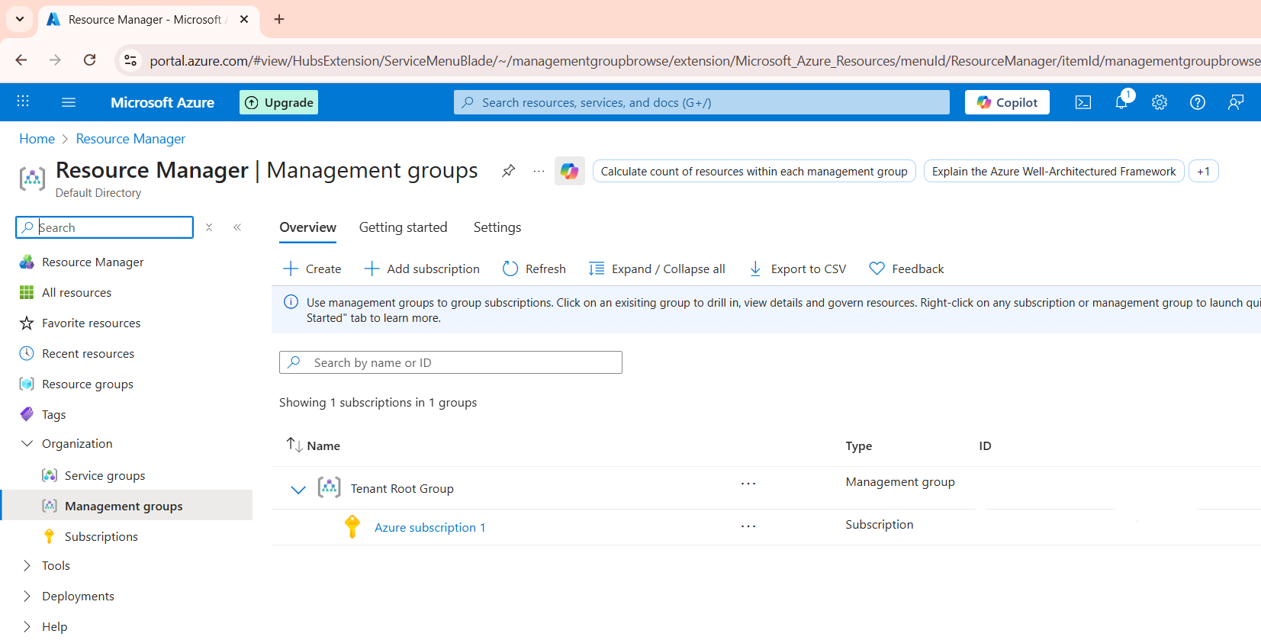

Subscriptions: They hold resources and manage access to resources.

Go to the Azure portal and search for Subscriptions.

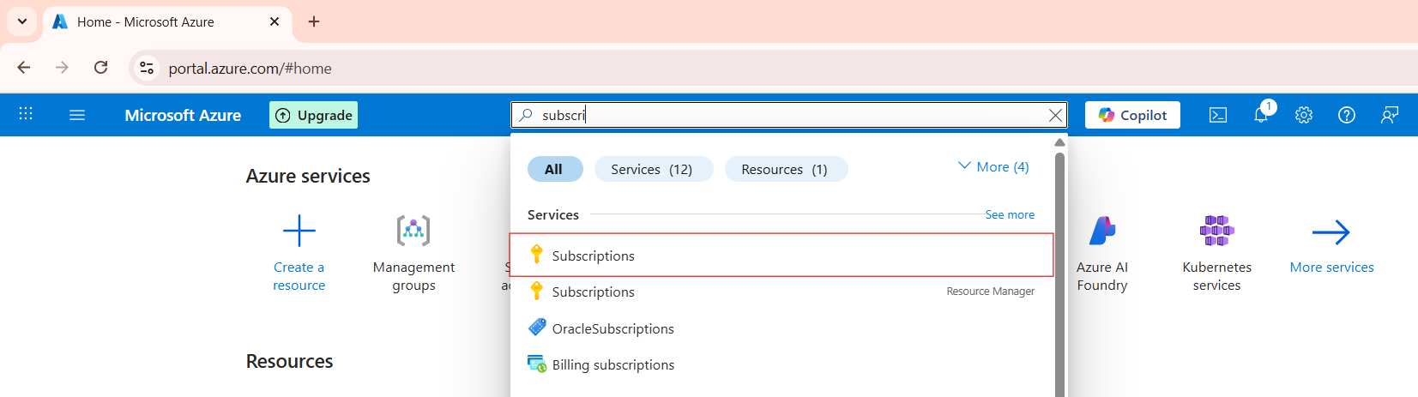

After that, click on the subscription to view the list of subscriptions

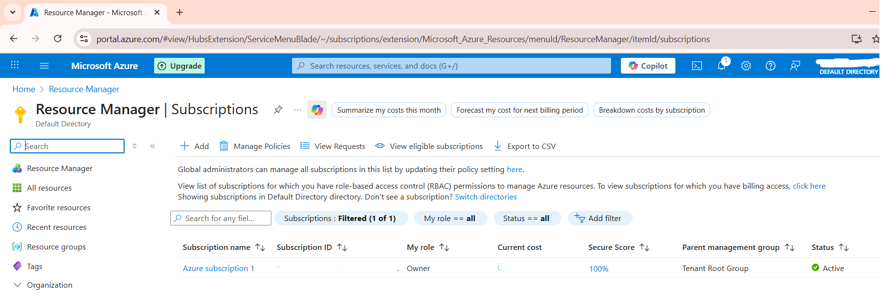

Resource Groups: Containers inside subscriptions to organize and manage resources by project or lifecycle.

Go to the Azure portal and search for Resource Groups.

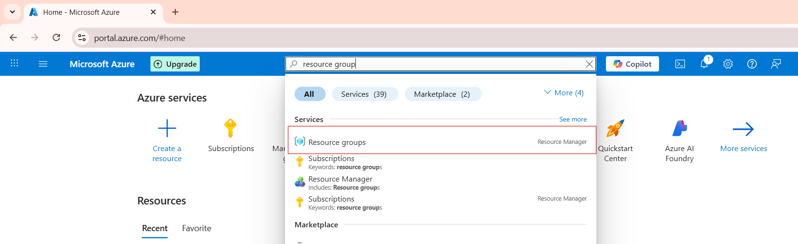

After that, click on the Resource Groups to view the list of Resource Groups.

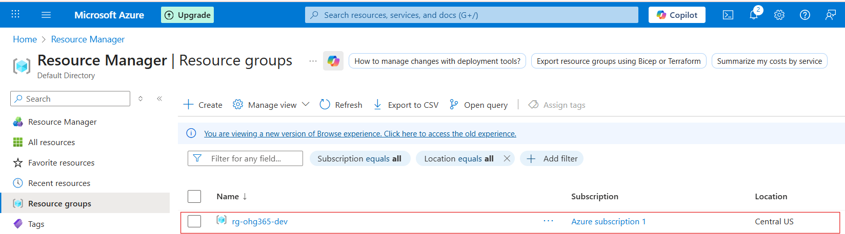

Resources: The actual services you use in Azure.

After clicking on the resource group, we can see all the resources inside it. All resources are automatically contained within the resource group.

